“It’s all basic really”

Y13 UNIT 4 TEST 6

4.3 ACIDS AND BASES

BOA SORTE!

Answer all questions
Total 50 marks

Name:………………………………………………………….

Mark for section A…………… /35

Mark for section C…………… /15

Total: ……………………………. /50

Grade……..
SECTION A

1. (a) (i) Write an expression for the dissociation constant Ka of propanoic acid, CH3CH2COOH.
Expression for Ka .............................................................................................
...........................................................................................................................
(ii) Write an expression for pKa in terms of Ka
Expression for pKa ...........................................................................................
...........................................................................................................................
(iii) Calculate the pH of a 0.10 M solution of propanoic acid, given that
Ka = 1.35 × 10–5 mol dm3 for this acid at 25°C.
...........................................................................................................................
...........................................................................................................................
...........................................................................................................................
...........................................................................................................................
...........................................................................................................................
...........................................................................................................................
(6)
(b) Explain why an aqueous solution containing propanoic acid and its sodium salt constitutes a buffer system able to minimise the effect of added hydrogen ions.
.....................................................................................................................................
.....................................................................................................................................
.....................................................................................................................................
.....................................................................................................................................
(3)
(Total 9 marks)

2. (a) Write an equation for the reaction which occurs when the weak acid HA is added to water.
.....................................................................................................................................
(1)
(b) Write an expression for the dissociation constant, Ka, for the weak acid HA.
.....................................................................................................................................
(1)

(c) The dissociation of the acid HA is an endothermic process. Deduce the effect, if any, of
(i) an increase in temperature on the value of the dissociation constant, Ka
...........................................................................................................................
(ii) an increase in temperature on the pH of an aqueous solution of the acid
...........................................................................................................................
(iii) an increase in the concentration of the acid on the value of Ka
...........................................................................................................................
(3)
(d) Identify a compound which could be added to aqueous ethanoic acid so that the pH of the resulting solution would not change significantly if a small volume of dilute hydrochloric acid were added. State the name given to solutions which behave in this way.
Compound...................................................................................................................
Name...........................................................................................................................
(2)
(Total 7 marks)
3. (a) At 25°C, the constant Kw has the value 1.00 × 10–14 mol2 dm–6. Define the term Kw.
.....................................................................................................................................
(1)
(b) Define the term pH.
.....................................................................................................................................
(1)
(c) Calculate the pH at 25 °C of 2.00 M HCl.
.....................................................................................................................................
(1)
(d) Calculate the pH at 25 °C of 2.50 M NaOH.
.....................................................................................................................................
.....................................................................................................................................
.....................................................................................................................................
(2)

(e) Calculate the pH at 25 °C of the solution that results from mixing 19.0 cm3 of 2.00 M HCl with 16.0 cm3 of 2.50 M NaOH.
.....................................................................................................................................
.....................................................................................................................................
.....................................................................................................................................
.....................................................................................................................................
.....................................................................................................................................
.....................................................................................................................................
.....................................................................................................................................
.....................................................................................................................................
(6)
(Total 11 marks)
4. Methylamine is a weak Brønsted-Lowry base and can be used in aqueous solution with one other substance to prepare a basic buffer.
(i) Explain the term Brønsted-Lowry base and write an equation for the reaction of methylamine with water to produce an alkaline solution.
Brønsted-Lowry base ...................................................................................
Equation .......................................................................................................
(ii) Suggest a substance that could be added to aqueous methylamine to produce a basic buffer.
......................................................................................................................
(iii) Explain how the buffer solution in part (a)(ii) is able to resist a change in pH when a small amount of sodium hydroxide is added.
......................................................................................................................
......................................................................................................................
......................................................................................................................
(5)
(Total 5 marks)

5. The pH curve for the titration of the weak diprotic acid H 2SO3 with aqueous sodium hydroxide is shown below.
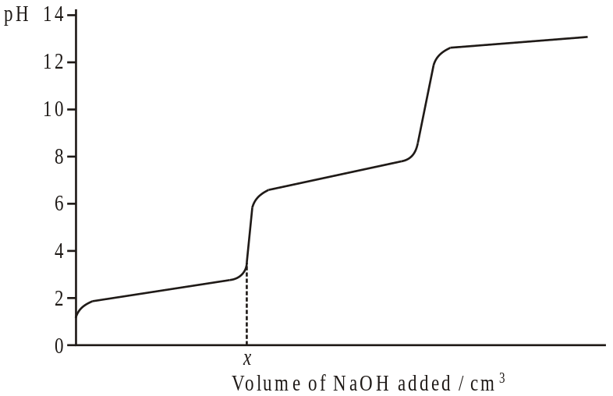
(i) Identify the sodium salt formed from H 2SO3 when x cm3 of NaOH have been added.
..................................................................................…....…..............................
(ii) Write an equation for the reaction that occurs between the two end-points (equivalence points).
..................................................................................…....…..............................
(iii) Name an indicator which could be used to determine the second end-point (equivalence point).
..................................................................................…....…..............................
(3)
(Total 3 marks)
SECTION B

6. A 0.210 mol dm–3 solution of potassium hydroxide was added from a burette to 25.0 cm3 of a 0.160 mol dm–3 solution of ethanoic acid in a conical flask.
Given that the value of the acid dissociation constant, Ka, for ethanoic acid is 1.74 × 10–5 mol dm–3, calculate the pH at 25 °C of the solution in the conical flask at the following three points:
before any potassium hydroxide had been added;
after 8.0 cm3 of potassium hydroxide solution had been added;
after 40.0 cm3 of potassium hydroxide solution had been added.
(Total 15 marks)

……………………………………………………………………………………………………………………

……………………………………………………………………………………………………………………

……………………………………………………………………………………………………………………

……………………………………………………………………………………………………………………

……………………………………………………………………………………………………………………

……………………………………………………………………………………………………………………

……………………………………………………………………………………………………………………

……………………………………………………………………………………………………………………

……………………………………………………………………………………………………………………

……………………………………………………………………………………………………………………

……………………………………………………………………………………………………………………

……………………………………………………………………………………………………………………

……………………………………………………………………………………………………………………

……………………………………………………………………………………………………………………

……………………………………………………………………………………………………………………

……………………………………………………………………………………………………………………

……………………………………………………………………………………………………………………

……………………………………………………………………………………………………………………

……………………………………………………………………………………………………………………

……………………………………………………………………………………………………………………

……………………………………………………………………………………………………………………

……………………………………………………………………………………………………………………

……………………………………………………………………………………………………………………

……………………………………………………………………………………………………………………

……………………………………………………………………………………………………………………

……………………………………………………………………………………………………………………

……………………………………………………………………………………………………………………

……………………………………………………………………………………………………………………

……………………………………………………………………………………………………………………

……………………………………………………………………………………………………………………

……………………………………………………………………………………………………………………

……………………………………………………………………………………………………………………

……………………………………………………………………………………………………………………

……………………………………………………………………………………………………………………

……………………………………………………………………………………………………………………

……………………………………………………………………………………………………………………

……………………………………………………………………………………………………………………

……………………………………………………………………………………………………………………

……………………………………………………………………………………………………………………

……………………………………………………………………………………………………………………

……………………………………………………………………………………………………………………

……………………………………………………………………………………………………………………

……………………………………………………………………………………………………………………

……………………………………………………………………………………………………………………

……………………………………………………………………………………………………………………

……………………………………………………………………………………………………………………

……………………………………………………………………………………………………………………

……………………………………………………………………………………………………………………

……………………………………………………………………………………………………………………

……………………………………………………………………………………………………………………

……………………………………………………………………………………………………………………

……………………………………………………………………………………………………………………

……………………………………………………………………………………………………………………

……………………………………………………………………………………………………………………

……………………………………………………………………………………………………………………

……………………………………………………………………………………………………………………

……………………………………………………………………………………………………………………

……………………………………………………………………………………………………………………

……………………………………………………………………………………………………………………

……………………………………………………………………………………………………………………

……………………………………………………………………………………………………………………

……………………………………………………………………………………………………………………

……………………………………………………………………………………………………………………

……………………………………………………………………………………………………………………

……………………………………………………………………………………………………………………

……………………………………………………………………………………………………………………

……………………………………………………………………………………………………………………

……………………………………………………………………………………………………………………

……………………………………………………………………………………………………………………

……………………………………………………………………………………………………………………

……………………………………………………………………………………………………………………

……………………………………………………………………………………………………………………

……………………………………………………………………………………………………………………

……………………………………………………………………………………………………………………

……………………………………………………………………………………………………………………

……………………………………………………………………………………………………………………

……………………………………………………………………………………………………………………

……………………………………………………………………………………………………………………

